|  |  |  |  |  |
| --- | --- | --- | --- | --- |
| **National University of Computer and Emerging Sciences, Lahore Campus** | | | | |
| C:\Users\saif\AppData\Local\Microsoft\Windows\Temporary Internet Files\Content.Word\final design.jpg | **Course:** | **Digital Logic Design** | **Course Code:** | **EE-227** |
| **Program:** | **BS (Computer Science)** | **Semester:** | **Spring 2020** |
| **Duration:** | **15 Minutes** | **Total Marks:** | **10** |
| **Paper Date:** | **10-June-20** | **Weight** | **2.5 %** |
| **Section:** | **D** | **Page(s):** | **1** |
| **Exam:** | **Quiz 4** | **Reg. No.** |  |
| **Instruction/Notes:** | **Calculators are strictly not allowed in all exams**  **Plagiarism will be dealt seriously causing an F in course** | | | |

Characteristic table of NP Flip-Flop is given below:

1. **Write the Characteristic equation of NP Flip-Flop. Show your working to get credit.**
2. **Fill in the excitation table of NP Flip Flop.**
3. **Draw its circuit and paste image in given box.  
     
     
   Circuit Diagram of NP Flipflop**

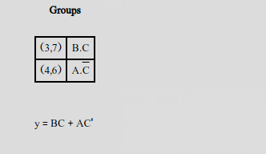 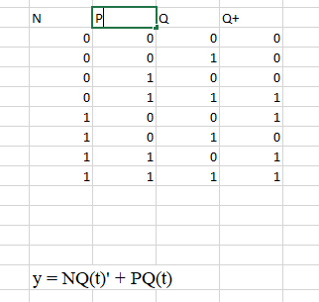 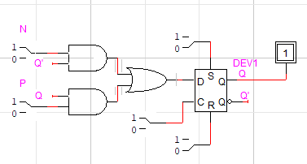

|  |  |  |  |  |  |  |  |  |  |  |  |  |  |  |  |  |  |  |  |  |  |  |  |  |  |  |  |  |  |  |  |  |  |  |  |  |
| --- | --- | --- | --- | --- | --- | --- | --- | --- | --- | --- | --- | --- | --- | --- | --- | --- | --- | --- | --- | --- | --- | --- | --- | --- | --- | --- | --- | --- | --- | --- | --- | --- | --- | --- | --- | --- |
| **Characteristic Table of NP Flip-Flop**   |  |  |  | | --- | --- | --- | | **N** | **P** | **Q(t+1)** | | 0 | 0 | 0 | | 0 | 1 | Q(t) | | 1 | 0 | Q(t)’ | | 1 | 1 | 1 |   **Characteristic Equation of NP Flip-Flop:**  **Q(t+1) = ___NQ(t)’+PQ(t)_________________** | **Excitation Table of NP Flip-Flop**   |  |  |  |  | | --- | --- | --- | --- | | **Q(t)** | **Q(t+1)** | **N** | **P** | | **0** | **0** | **0** | **X** | | **0** | **1** | **1** | **X** | | **1** | **0** | **X** | **0** | | **1** | **1** | **X** | **1** | |